

Architecture Document for
<Project Name>

.........
<Project>-<Component>-AD-<Version>

Table of Contents

1 Introduction 1
1.1 Purpose 1
1.2 Scope 1
1.3 Definitions, Acronyms and Abbreviations 1
1.4 References 1
2 Architectural Goals and Constraints 2
2.1 Reusability 2
2.2 Scalability 2
2.3 Customizability 2
2.4 Extendibility 2
2.5 Use of Existing Business Logic 2
2.6 Time to Market 2
2.7 Portability 2
2.8 Availability 3
2.9 Performance 3
2.10 Any Other Critical Goals Applicable 3
3 Productization Assessment 4
3.1 Re-Usable Components 4
3.2 Analyze Architectural Frameworks in Repository 4
3.3 Identify and Analyze Open Source and COTS Products 4
4 System Architecture 4
4.1 Overview 4
4.2 Logical/Functional View 5
4.3 Use Case View 8
4.4 Implementation/System View 8
4.5 Process/Thread View 9
4.6 Deployment View 9
5 General Architecture for Core Technical Services 11
5.1 Persistence 11
5.2 Inter-process Communication 11
5.3 Authentication and Authorization 11
5.4 Error Handling 11
5.5 Logging 11
5.6 Transaction Management 11
5.7 Other Applicable Technical Services 12
6 Risks/Limitation 13
7 Alternative Solutions Considered 14
Appendix 15
1. Expected Software Response 15
2. Performance Bounds 15
3. Identification of Critical Components 15
4. Review Comments on Architectural POC 15
5. Justification of Changes to Existing Architecture (Optional) 15

Document Revisions
Date | Version | Description | Author

Note: These documents are strictly for specific Virtusa/client use only. They shall not be shared with an external party other than the client concerned. These documents should always be kept securely and employees shall use reasonable care protecting these documents from unauthorized use or disclosure to a third party. This category also covers client intellectual property where Virtusa has a non-disclosure agreement with the client.

Document Approval

Virtusa Corporation and <Client>have reviewed this document and hereby agree that the contents herein are accurate. Any changes to this document must be communicated in writing and signed-off by both parties.

Signature | Signature
Date: | Date:
Name: | Name:
Client: <Client> | Virtusa Corporation

Template User Notes:

Help Info is provided (in blue italics) to describe what each section should contain. Sample Text is provided (in green) in some sections to assist the author in standard wording for common documentation. Macro Buttons (in blue bold italics) must be replaced to match the project, e.g. <Project.

Note: Help Info and Sample Text are included to provide guidance to the author and should be deleted before publishing the document.

Introduction

Purpose

This document provides a comprehensive architectural overview of the <Project Name and Application Name> system, using a number of different architectural views to depict different aspects of the system. It is intended to capture and convey the significant architectural decisions, which have been made on the system.

Scope

[This sub-section provides a brief description of the scope of the document, i.e., the areas affected by this project and those areas that are out of scope of the project.]

Definitions, Acronyms and Abbreviations

[This sub-section must provide definitions for all the terms, acronyms, and abbreviations used in this document.]

References

[This sub-section must provide a complete list of all references. Identify each document by title, document number and the version. Specify the sources from which the references can be obtained.]

Architectural Goals and Constraints

[This section describes the requirements and objectives that have some significant impact on the architecture: use of an off-the-shelf product, portability, distribution, and reuse. It also captures the special constraints that may apply: for example, development tools, legacy code, and so on. Document assumptions, if any, for each architectural goal that is described.]

Reusability

User interface related components will be used for the second phase of the back-end data server enhancement project. Therefore, the core of the UI system must be reusable in the second phase RDBMS based enhancement project.

Scalability

The system should scale well. The limitation will be the current application and flat file system.

Customizability

UI customization will be supported.

Extendibility

The system should be extendible to support new features and to allow modular development.

Use of Existing Business Logic

The system should use the existing application’s business logic by moving it into a reusable component such as a DLL.

Time to Market

Time constraints to market. This will affect the choice of technology. E.g. VB COM vs. ATLs.

Portability

OS and database portability.

Availability

Uptime constraints and fault tolerance needs.

Performance

Any performance criteria.

Any Other Critical Goals Applicable

Productization Assessment

Re-Usable Components

This section specifies the information relating to the reuse analysis performed by the Productization specialist with the requirements document as input. It lists the reusable components and describes the commonality and variability analysis

Analyze Architectural Frameworks in Repository

This section analyzes frameworks in the repository that can be reused in the architecture under discussion.

Identify and Analyze Open Source and COTS Products

This section documents the open source and COTS products identified for use in the project along with the copyright and legal approval needs.

System Architecture

This section describes the software architecture of the current system, and how it is represented. Out of the Logical, Use Case, Implementation, Process and Deployment views, it enumerates the views that are necessary, and for each view, explains the types of model elements it contains.

Models | XML compliant tool
Diagrams | .svg format

Overview

The application is comprised of several key architectural components that are independent functions related only via the defined interfaces.
The application is divided into three tiers: User Interface Services, Business Services and Data Services. Each layer is responsible for handling a well-defined area of the application.

Logical/Functional View

This sub-section describes the system architecture at a high-level. The aim is to provide a logical architecture diagram to document the:
- Logical components of the layers and partitions of the application
- Logical relationships between them

The application is comprised of several key architectural components that are independent functions related only via the defined interfaces.
Option 1: (Use block diagrams)

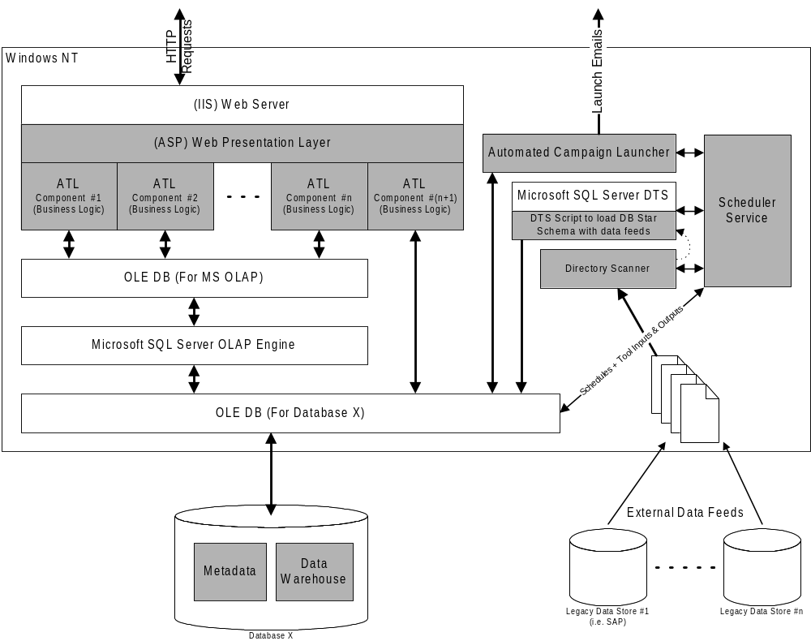

FIGURE 1: Sample Project Application Architecture Overview
Option 2: Package and Layering Diagram (preferred)

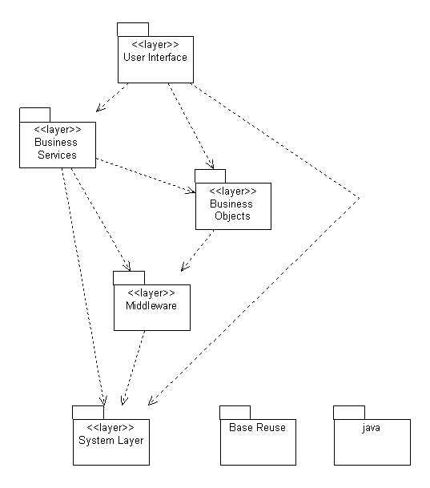

The application is divided into three tiers: User Interfaces Services, Business Services and Data Services. Each layer is responsible for handling a well-defined area of the application.

Use Case View

[This sub-section lists use cases or scenarios from the use-case model if they represent some significant, central functionality of the system, or if they have a large architectural coverage - they exercise many architectural elements, or if they stress or illustrate a specific, point of the architecture.]
Example diagram:
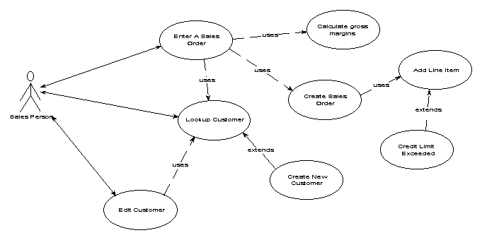

Implementation/System View

[This sub-section describes the overall structure of the implementation model, the sub-systems, and classes in the implementation model that are architecturally significant implementation elements.]

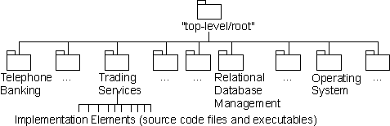

Process/Thread View

[This sub-section describes the process flow of the system or a major component.]

Example diagram:
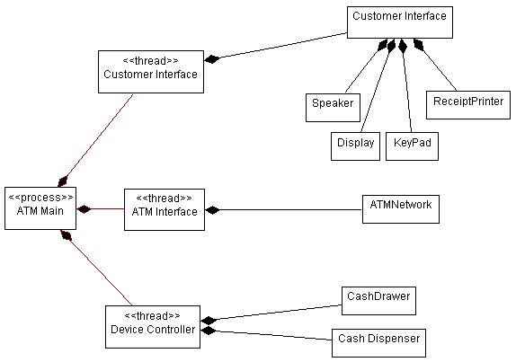

Deployment View

[This sub-section describes one or more physical network (hardware) configurations on which the software is deployed and run. It is a view of the Deployment model. At a minimum, for each configuration it should indicate the physical nodes (computers, CPUs) that execute the software, and their interconnections (bus, LAN, point-to-point, and so on.) Also include a mapping of the processes of the Process View onto the physical nodes.

This section also describes the deployment environment.]

Example diagram:

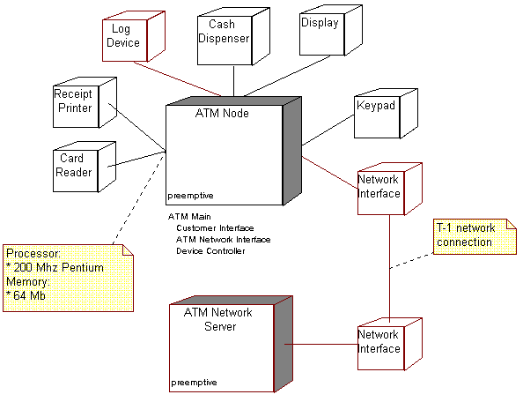

General Architecture for Core Technical Services

[This section describes the design strategy, trade-offs, alternative solutions considered, and the Build, Buy or Reuse analysis related to the core technical services for the system.]

Persistence

[This sub-section describes the strategy, trade-offs, alternative solutions considered, and the Build, Buy or Reuse analysis related to the persistence services for the application.]

Inter-process Communication

[This sub-section describes the strategy, trade-offs, alternative solutions considered, and the Build, Buy or Reuse analysis related to the inter-process communication framework for the application.]

Authentication and Authorization

[This sub-section describes the strategy, trade-offs, alternative solutions considered, and the Build, Buy or Reuse analysis related to the security services for the application.]

Error Handling

[This sub-section describes the strategy, trade-offs, alternative solutions considered, and the Build, Buy or Reuse analysis related to the error handling services for the application.]

Logging

[This sub-section describes the strategy, trade-offs, alternative solutions considered, and the Build, Buy or Reuse analysis related to the logging framework for the application.]

Transaction Management

[This sub-section describes the strategy, trade-offs, alternative solutions considered, and the Build, Buy or Reuse analysis related to the Transaction Management service for the application.]

Other Applicable Technical Services

[This sub-section describes the strategy, trade-offs, alternative solutions considered, and the Build, Buy or Reuse analysis related to other core technical services to be handled by the system such as the installation mechanism, failure prevention, fault tolerance, caching design, internationalization, validation framework, client and server initialization, error handling, etc.]

Risks/Limitation

[This section describes the risks/limitations of the architecture.]

Alternative Solutions Considered

[This section describes the alternative architectural solutions that have been considered and explains the rationale for selecting the current solution.]

Appendix

[Present information that supplements the architecture specification.]

Expected Software Response

[Describe the expected results from testing.]

Performance Bounds

[Describe the special performance requirements.]

Identification of Critical Components

[Identify those components that are critical and demand particular attention during testing.]

Review Comments on Architectural POC
[If an architectural POC was developed and reviewed, elaborate the review comments for the POC.]

Justification of Changes to Existing Architecture (Optional)

[If any changes are made to an existing architecture to account for the new behavior, document those changes.]

